

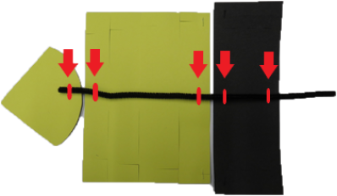
Instructions
- Print on yellow card and cut out pieces.
- Carefully make cuts as shown by the dotted lines.
- Use the templates to cut 1 waist and 2 eyes from black card.
- Use the thorax template to cut a width of A4 black card.
- Arrange the thorax, abdomen and last segment pieces in a line. Staple a pipe cleaner to these pieces as shown, stapling from the inside to secure it.

- Staple the wings onto the thorax
- Fold the last segment into a cone shape and secure with a staple.
- Bend each abdominal section into a circle, slipping the slots together to secure it
- Thread 3 pipe cleaners through the holes in the thorax to make 6 legs.
- Bend the thorax into a circle, slipping the slots together to secure it.
- Bend the sides of the head together, slipping the slots together to secure it.
- Staple the bottom edges of the head together
- Staple the thorax end of the pipe cleaner onto the flap forming the top of the head. Push the end, attached to the tab into the slot.
- Attach the eyes to the head by pushing the tabs into the slots.
- Attach the waist to connect the thorax and abdomen by pushing the tabs into the slots.
- Attach a string or thread to the pipe cleaner between the thorax and abdomen.
Your wasp puppet is ready!
Eye template - cut 2 from black card
Waist template
Thorax template -
cut from black card

